PROJECT BREW INN - DESIGN DOC

This document will be periodically updated.

Last update: Wednesday 19/02/24 ~ Skye

**Designers! Remember to log your changes in the update record.**

**Standardisation and common values 3**

Assets - External world 3

Assets - Tavern 3

Systems - Core gameplay 3

Systems - Farming 3

Systems - Production 4

**Universal game systems 5**

Global ticks 5

Day / night cycle 5

Universal currency 6

Player universal inventory 6

Experience / proficiency system 7

Overview 7

EXP sources table 7

EXP progression table 8

Licenses 9

Overview 9

License table 9

**External world 11**

Overview 11

Tile system 11

Expansion 12

Base ground tiling 12

Key world structures 13

Tavern 13

Warehouse storage 14

Trading and hiring centre 14

Other world structures 14

Road and parking 14

Waterfront and harbour 14

Time 15

**Farming structures 16**

Abstract farming system 16

Irrigation structures 16

Orchard / trees 17

Bushes and vines 18

Herb & spice garden 19

Greenhouses 19

General farming concept art 19

**Farming implementation and crops 21**

Crops table 21

Resources table 22

**Production machines 23**

Abstract production system 23

Juicer 23

Slicer 23

Crusher 23

Strainer 23

Fermenter 23

Aging barrels 24

Washer 24

Mixing vat 24

Industrial cooker 24

Industrial chiller 24

Water processing unit 24

Dehydrator 24

Bottling unit 24

Transport pipes 24

**Tavern interior 25**

Overview 25

Layout 25

General seating area 27

Bar area 27

Counter tops 27

Storage units 28

Lighting 28

Cellar 28

Storage units 28

**Update record 29**

# Standardisation and common values

## Assets - External world

The art style for the external world is 2D pixel art. Assets are viewed from a similar angle to Stardew valley. (A few degrees off top-down view.)

Tile size for artists is currently set at **128 x 128 pixels** per tile. This is expected to be finalised once the base tiles are up for review. The wording here will be updated accordingly.

Asset sizes will be given to artists with references to both tiles and pixels where possible. For example, an asset that takes up a *3x3 tile* space takes up *384 x 384 pixels*.

## Assets - Tavern

[This section will be populated as applicable]

## Systems - Core gameplay

Gameplay exists in a day/night time cycle. Each day night cycle is **24 minutes long**. Night exists for the **last 8** of these minutes.

The majority of crops’ growth rate during the day takes 2 minutes, with specific ones taking 4 minutes.

Balancing trade values are all to be made against the value of **1 gold** (or whatever we end up calling the centralised currency, updates as appropriate).

Global tick speed is to be set at ***[TBD]***.

## Systems - Farming

The ***night growth rate debuff*** has farming **slow** **by a base amount of** **25*%* during the night phase** of the day night cycle. This applies to crops unless otherwise specified.

The ***irrigation access*** check returns *true* when **the specific structure tile is** **within a 5x5 square** centred on the *irrigation tile* with water.

The ***irrigation expanded***check returns *true* when **any tile of a structure is within 13x13 square** centred on the *irrigation tile* with water.

The ***storage access***check is used when a farming structure has a separately placed *storage tile*. This check returns *true* when the structure has access to at least one of its *storage tiles* as the tile is connected through adjacent tiles (cardinals only, no diagonals) of the *body tile* type for that structure.

## Systems - Production

*Provide* interactions with a machine transfer the selected number of resources from the *player’s universal inventory* to the *local storage* of the machine. This can either be by direct player interaction or automation via *workers.*

*Retrieve* interactions with machines transfer the resources in the machine’s *local storage* to the *player’s universal inventory.* This can be either by direct player interaction or automation via *workers*.

*Take* interactions with a machine remove the resources in the machine’s *local storage* as to add them to another machine’s *local storage*. This mainly occurs via *transport pipes*.

*Give* interactions add resources to a machine’s *local storage* originally taken from another machine’s *local storage.* This mainly occurs via *transport pipes.*

# 

# Universal game systems

## Global ticks

**System requirements summary:** *Global tick system to act as a time system for reliant systems. Secondary tick system (either built in or separately triggered) for night time farming that implements debuff. Should be located in the global functionality scene. Preferably is held in the same state when the game is paused.*

**Asset requirements summary:** *No assets are required for this system.*

**Description:** To allow for a standardised growth system while avoiding excess reliance on timers; a number of systems are to be designed based on a global tick system.

The global tick system should run at ***[TBD]*** ticks per seconds. The occurrence of each tick should be broadcast such that relevant game systems are able to respond.

Global ticks occur throughout gameplay regardless of whether the player is in the external world or within the tavern. The only time the tick system should not be progressing is if the player has paused the game.

A secondary tick system for crop growth should be built on the global tick system. The second tick system is needed to apply the *night growth rate debuff* as this slower tick rate should ***not*** be applied to the global ticks. This may be built into the global ticks or built separately and triggered during the night phase. Technical discretion should be applied for specific implementations.

## Day / night cycle

**System requirements summary:** *An implementation of a day/night state record that is timer based. Preferably holds the same state when the game is paused. Should be in the global functionality scene. Display of the correct icon in the UI.*

**Asset requirements summary:** *Simple icons for morning, day, afternoon, evening, nightfall, late night based on the sun and moon. Day and night filters/ overlays for the external world.*

**Description:** The gameplay world exists within a *day / night cycle*. Each cycle lasts 24 minutes beginning with a 16 minutes day phase followed by a 8 minutes night phase. The time cycle continues regardless of what scene the player is in ***except*** when the game is paused.

While system dependencies are based on the binary day/night state, the player should be provided with information of roughly how far into each phase they are. Exact clocks are not to be displayed to players. Icons for morning, day, afternoon and evening using the sun should be made to indicate what section of the day phase the player is in, changing at the start of 4 minute subsections. Icons for nightfall and late night using the moon should be made for the same effect with 4 minute subsections of the night phase.

The *day* and *night phases* should also have some effect on the visuals of the external world. The anticipation is that this is best completed through some form of filter or overlay to the world.

The main daytime overlay should provide the appearance of the world being brighter, probably with some hues around yellows, oranges, light blues and whites *[I think this works, but I’m not an artist so this may just be dead wrong. Treat these suggestions as such! ~ Skye]*. These should not be too saturated and should be mostly transparent. The player should be able to see the world after all!

The main nighttime overlay should function similarly, but to make the world feel darker. This likely uses darker blues and greys *[Again; I think this works, but I’m not an artist so this may just be dead wrong. Treat these suggestions as such! ~ Skye].* Again, the overlay should be mostly transparent and the colours not too saturated.

It would also be preferable to have some transition overlays for the day/night cycle featuring reds, pinks, oranges and blues. The nature of this/these is mostly at artistic discretion.

## Universal currency

**System requirements summary:** *Currency counter and means of editing the total coded in the global functionality scene. Display of current currency within the UI.*

**Asset requirements summary:** *Icon for currency*

**Description:** A single universal currency is used throughout the game as the standardised resource. The amount of this currency that the player has should be tracked in all environments.

Currency may be spent at a number of points including in the trading centre and when paying workers. As such, currency should be changeable in most game states (except pause).

## Player universal inventory

**System requirements summary:** *Inventory split by resource categorisation. Inventory record that can be added to / removed from on interaction within world structures. Player can view inventory through menu / UI. Player can use items in their inventory within production structures to refine resources. Player can access inventory categories within tavern gameplay through interactions at set locations.*

**Asset requirements summary:** *Specific UI / menu elements for the inventory. Other assets can be shared with other parts of the game.*

**Description:** The player’s resources are managed through a universal inventory system. This is separate from the *local storages* of structures that can be placed in the external world.

When an interaction occurs to *retrieve* resources from a structure in the external world, those resources are transferred to the *player’s universal inventory.* This transfer does not require any additional, specific infrastructure to be built by the player.

When an interaction occurs to *provide* resources to a structure in the external world, the resources provided are transferred to the structure’s *local storage*. This transfer does not require any additional, specific infrastructure to be built by the player.

Resources transferred between structures in the *production zone* by means of *transportation pipes* act as *take* and *give* interactions. These interaction do not transfer resources to or from the *player’s universal inventory*.

Overall inventory management functionality can be accessed through the *warehouse structure* in the *external world*. Specific inventory management functionality can be accessed through placed structures where the functionality mirrors the interaction types required for the structure to operate. Within the *tavern interior*, different categories of resources can be accessed through different interaction points.

## Experience / proficiency system

### Overview

**System requirements summary:** *Exp tracker within the global functionality scene. Progress bar and EXP level indicator within UI elements. Functionality to increase EXP by set increments. Locking features behind levels. Reward / resource provision at level up.*

**Asset requirements summary:** *Progress bar, EXP icon*

**Description:** Progression is monitored through an *EXP/proficiency system*. While the name of this system is very much subject to change, this is a single progression system based on experience points. For the current version of this section, it will be referred to as the *EXP system*.

### EXP sources table

| ***Source*** | ***EXP granted*** |
| --- | --- |
| *Orchard* harvest |  |
| *Bushes and vines* harvest |  |
| *Crop plot* harvest |  |
| *Herb and spice garden* harvest |  |
| *Greenhouse* harvest |  |
| *Drink served* |  |
| *Structure placed (Category 1)* |  |
| *Structure placed (Category 2)* |  |
| *Structure placed (Category 3)* |  |
|  |  |

### EXP progression table

| ***EXP level*** | ***EXP needed for next level*** | ***Licenses unlocked for purchase*** | ***Farming structures unlocked for purchase*** | ***Production structures unlocked for purchase*** | ***Flat resources / structures awarded*** |
| --- | --- | --- | --- | --- | --- |
| 0 |  |  |  |  | *Orchard* (lvl 1) x1;  *Irrigation* (source) x1;  *Irrigation* (main) x2;  *Juicer* x1;  *Washer* x1 |
| 1 |  |  |  | Bottling (lvl 1) |  |
| 2 |  |  | Orchards (lvl 1) |  |  |
| 3 |  | System unlocked;  Juices;  Ciders. |  | Fermenter | Juices license;  Transport pipes (lvl 1) x20. |
| 4 |  |  | Irrigation (source);  Irrigation (main) | Washer (lvl 1) |  |
| 5 |  | Teas |  |  | Currency xN |
| 6 |  |  | Bushes (lvl 1) |  |  |
| 7 |  |  |  | Transportation pipes (lvl 1) |  |
| 8 |  |  |  | Water processing unit |  |
| 9 |  |  |  | Industrial mixer |  |
| 10 |  |  |  |  | Currency xN;  Syrup xN |
| 11 |  |  |  | Dehydrator |  |
| 12 |  |  | Crop plots (body);  Crop plots (storage) | Industrial cooker |  |
| 13 |  |  |  | Carbonator |  |
| 14 |  |  |  |  |  |
| 15 |  |  |  |  |  |

## Licenses

### Overview

**System requirements summary:** *Ability to purchase licences. Locking drinks / resources behind licences.*

**Asset requirements summary:** *Generic licence certificate icons*

**Description:** Licenses are the system through which the player is able to obtain the ability to refine certain resources and make certain drinks. Licences are unlocked for purchase through progression in the EXP system.

Licences are introduced to the player during the tutorial section and the system is unlocked at EXP level 3. Until this point, the game can act as if the player has the *juices* license.

### License table

***The licence table below is currently being populated and the information is subject to change. Please treat the information within accordingly.***

| ***License name*** | ***Unlocks at EXP*** | ***Purchase cost*** | ***Drinks unlocked*** | ***Refinements unlocked*** |
| --- | --- | --- | --- | --- |
| Juices | 3 | 0 | All fruit juices  All berry juices |  |
| Teas | 5 |  | Loose leaf tea;  Iced teas |  |
| Classics |  |  | Lemonade;  Fruit squash (+mix);  Berry squash (+mix); |  |
| Ciders (Basic series) | 3 |  | Apple cider;  Pear cider  Forest berry cider |  |
| Ciders (Specialty series |  |  |  |  |
| Hot drinks |  |  | Coffee;  Hot chocolate; |  |
| Beers |  |  | Ginger ale; |  |
| Wines |  |  |  |  |
| Cocktails (Series 1) |  |  |  |  |
| Cocktails (Series 2) |  |  |  |  |
| Seasonal favourites |  |  | Pumpkin spice latte;  Mulled wine |  |

# External world

## Overview

***For the purposes of this document, north is considered to be at the top of the screen when viewing the external world.***

The external world is a 2D space divided into a few key sections, namely the *farming zone, production zone* and the set world elements. All three share a single standardised tile system which is used for the placement of infrastructure and set world elements. The standardisation also provides standardised build scaling for all assets as assets are expected to follow the common tiling size for art.

Set world elements exist across the southern part of the screen. These include the *tavern, storage warehouse, trading and hiring center,* road, parking area, signage, *harbour*, and waterfront. The road continues eastward and the waterfront continues westward. Above these exist the *farming zone* (that expands northward and westward from the central origin line) and the *production zone* (that expands northward and eastward from the central origin line). The *farming* and *production zones* do **not** overlap and are separated by the central origin line at *coordinate x=0*.

## Tile system

**System requirements summary:**

**Asset requirements summary:**

**Description:** The external world is built on a central tile system. All things placed into the world (either by the game on starting a new run or by the player during the course of gameplay) take up a set number of tiles. No structures can overlap meaning tiles can only contain a single structure / part of a structure.

Tiles should be referable by a coordinate system. (This may be changed if the technical implementation is optimised by a different solution. Techs/coders should communicate this to the design team and this part of the documentation will be updated accordingly as appropriate.) The origin line at x=0 should run between the farming and production zones. The coordinate system should be suitable such that information storage for the different structures can address a location on the tile map. This is such that the gameplay state can be saved between sessions.

The tile system should be built in a manner that allows structures to be larger than a single tile (but sized at an integer multiples in the X and Y directions). Structures that are larger than one tile should still be referenced by a single coordinate (technical discretion should be used in determining which reference this is). For example, a structure that takes up a 2x3 tile space should still be addressable by a single coordinate reference for save purposes while also occupying all 6 tiles as a structure.

## Expansion

***This section is actively being altered and the information within it is likely to change.***

[This section will be populated in due course.]

**System requirements summary:**

**Asset requirements summary:**

**Description:**

## Base ground tiling

**System requirements summary:**

**Asset requirements summary:**

**Description:** The *external world* has 5 main base tiles forming the ground of the gameplay region. This is split between the *production zone,* *farming zone* and a transition between the two.  
  
Within the *farming zone*, there should be two tile sets: grass and dirt. The grass and dirt tile sets should be separate assets. The grass tiles constitute the primary tiles for the farming zone with patches of dirt. This is likely to be completed through layering of tiles. As such, each tile set should have a small set of *main body tiles***(**used to constitute most of the tiles of that type with some small variation of texture) as well as a set of *edge piece tiles* which can be overlaid over another tile to provide some sort of transition. The edge piece tiles should fill the majority of the tile space but **not** fill the entire tile space. The tiles should be comparatively more vibrant and feel like the land is looked after.

Within the *production zone*, there should be two tile sets: coarse dirt and gravel. The design fundamentals of these tiles are the same as those for the *farming zone*. Tile sheets should have some variation for the *main body tiles* and also include *edge piece tiles.* Coarse dirt forms the primary base tile with patches of gravel interspersed within the world. The tiles should be comparatively more ‘industrial’ and ‘practical’ while also being less saturated.

Between the two zones, some form of transition tile is to be created. The tile should feel like a blend of the grass and the course dirt from the *farming* and *production zones* respectively. The specific design of these tiles defers significantly to artistic freedom within the confines of fitting with the other base tile sets. While it would be useful to have some variation in this tile set, the tiles will be used significantly less than the other tiles and therefore can have less variation. The tiles should be formed with some *main body tiles* as well as *edge piece tiles* as either one may be used in the final build.

## Key world structures

### Tavern

**System requirements summary:**

**Asset requirements summary:**

**Description:** The *tavern* *building* is located at the southern point of the *origin line*. Interaction with the tavern building allows the player to access the *tavern interior* where the second gameplay aspect occurs.

The *tavern building* is a rustic and mediaeval inspired structure primarily made out of wood and stone. Key structural elements are highlighted with wooden framing with stone frames used for more fundamental structural frames. The building has two main sections, one relatively rectangular shaped 2 story section and an expansion on the ground floor. Windows should rest upon wooden window sills and may be accompanied by wooden shutters (this call is to be made by the artist to fit the asset). Windows should also have a small roof above each of them.The front door should be mostly wooden with a relatively large vertical handle and window in the top half. The doorframe should be either stone or timber, keeping a consistent outline of the door. A tavern sign should be seen hanging from the wall, but the image on it can be generic or not-visible (artistic discretion should be used). It is preferable if the asset also contains a pathway to the door from the bottom of its lowest tile.

Concept art for the 3D tavern ***before*** *the Wed 05/02/25 rescope decision* is shown below.

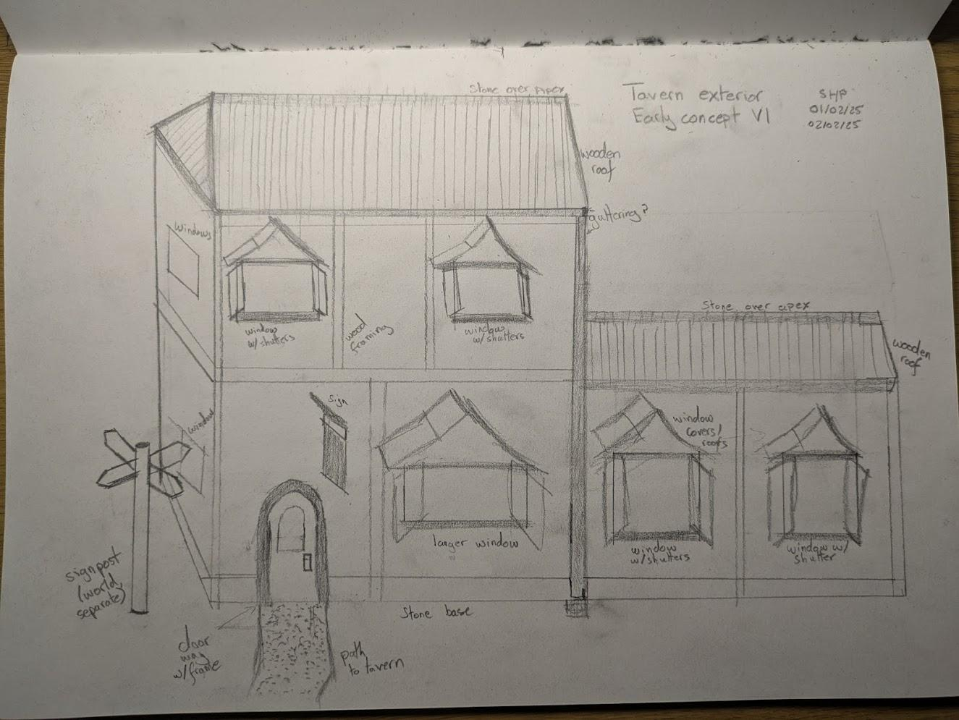

### Warehouse storage

**System requirements summary:**

**Asset requirements summary:**

**Description:** The *warehouse building* contains the centralised storage inventory for the *external world.* Interacting with the *warehouse building* allows the player to access the *storage menu*.

### Trading and hiring centre

**System requirements summary:**

**Asset requirements summary:**

**Description:** The *trading and hiring centre* serves as the hub for two mechanics: purchasing equipment & resources and hiring workers.

## Other world structures

### Road and parking

**System requirements summary:**

**Asset requirements summary:**

**Description:** These structures do not serve a gameplay function beyond world building and aesthetics. The *road* should be tileable as the road is the southernmost limit that extends eastward.The road should be accompanied by either pavement or a pedestrian path to its immediate northern side and some form of greenery to the immediate southern side. The *parking area* should be relatively simple and can ‘extend’ beyond the lower boundary of the world but should be immediately recognisable. Within the context of the world, this parking area serves the *tavern,* *waterfront* and *harbor*.

### Waterfront and harbour

[Section will be populated in due course.]

**System requirements summary:**

**Asset requirements summary:**

**Description:**

## Time

**System requirements summary:**

**Asset requirements summary:**

**Description:** The world exists in a day / night cycle. Each cycle is 24 minutes long and forms one in world day.

The day cycle lasts for 16 minutes and is the functional base state of the external world.

The night cycle lasts for 8 minutes and applies the night modifiers to the world. These include reduced rate of crop growth and workers resting (not completing their assigned task).

When the game commences, the player starts at day 1. The day counter increases at the start of each subsequent day cycle. This statistic should be tracked as the player will be shown both the day count and some indication of their position in the day/night cycle either in the UI or in a menu. This applies to each separately.

# 

# Farming structures

## Abstract farming system

In general, farming systems are designed to contain a number of standardised systems which can be applied to implemented systems through object inheritance. As such, an abstract base class or implemented parent class is appropriate.  
  
This parent class should include the base versions for the following attributes and methods:

* Growth timer
* Night cycle debuff
* Manual harvesting
* Automatic harvesting
* Local tile inventory
* Resource collection

*(This list may be updated should further features be added, updates will be made clear and amendments will be made here as appropriate.)*

These features should work as follows, where X and Y are input values / set value for the child class.  
Growth timer*: X minutes per harvest*

Night cycle debuff: *X% slower crop growth during the night phase of the day/night cycle. This may be implemented as an increase to the timer of Y%.****\****

Manual harvesting: *On player instigated trigger, harvest the X many crops and add them to the local inventory.*

Automatic harvesting: *X minutes after the end of the last growth cycle,* ***if there has not been a manual harvest****, automatically harvest X many crops and add them to the local inventory.*

Local tile inventory: *a localised storage for harvested crops, maxing at X many crops.*

Resource collection: *means of collecting crops from the local tile inventory (removing them from the tile) and adding them to the centralised warehouse storage.*

***\****(The preferred method of implementation by the tech/ code team should be fed back to designers so that balancing and design decisions can be made accordingly. The decision will also be reflected here.)

## Irrigation structures

**Size:** *Well - 1x1 (128x128 pixels); main - 1x1 (128x128 pixels); split - 1x1 (128x128 pixels); turn - 1x1 (128x128 pixels)*

**Checks:** *Water*

**Unlocks at:** *Source & main - EXP 6; split & turn - EXP X*

The irrigation system is created from a series of 1x1 tilesthat can be connected. There are 4 types of tile that are used for this: *well* (source), *main, split* and *turn.*

*Well tiles* act as the source for connected tiles. *Wells* can be connected to from all four cardinal directions. *Wells* provide enough water for 10 tiles as followed through the system (well acts as tile 0). Irrigation checks on wells should always return *true*.

*Main tiles* are expected to constitute most of the made irrigation systems. These act as an irrigation tile that can be connected to in a straight line. If a *main tile* is within 10 tiles of a well (as measured through the connected system), irrigation checks should return *true*. In all other cases, the irrigation check should return *false*.

*Split tiles* follow the same irrigation check logic as the *main tiles*. Connections made through a *split tile* form a T shape.

*Turn tiles* also follow the same irrigation check logic as the *main tiles*. Connections through *split tiles* turn the direction of the system by 90 degrees.

Ideally, functionality will be built in that allows the player to rotate these tiles before placing them so that custom irrigation layouts can be created.

*Irrigation access* and *irrigation expanded checks* are based on the area around placed irrigation tiles with water. *Irrigation access* checks are *true* in the 5x5 square centred on the irrigation tile. *Irrigation expanded* checks are *true* in the 13x13 square centred on the irrigation tile.

## Orchard / trees

**Size:** *3x2 (384x256 pixels)*

**Checks:** *Irrigation expanded; level penalty*

**Unlocks at:** *EXP 2 (+2 base on game start)*

**Upgrade unlocks at:** *EXP X*

*Orchard* structures are the first farming structure that the player encounters. Players start the game with 2 *orchards.* The player unlocks the ability to purchase further *orchards* at *EXP level* ***2****.*

*Orchards* take up a 3x2 tile space. *Orchards* have an upgraded second level that is unlocked at *EXP / proficiency* ***[TBD]***. There should be some visual changes for the second level that builds on the base version of the asset.  
  
*Orchards* contain 6 trees and therefore produce multiple of a crop per harvest. All trees in an *orchard* structure are used for the same crop and are harvested at the same time. At *level 1*, *automatic harvesting* incurs a penalty and collects a reduced number of products as some are ‘lost’ having been made unsafe after falling from the trees. At *level 2*, this penalty is set to 0.

*Orchards* require access to an irrigation system through the *irrigation expanded* check. This requires **any** of the 6 tiles of the *orchard* to be within 7 tiles of the nearest *irrigation tile* with water.

## Bushes and vines

**Size:** *3x1 (384x128 pixels)*

**Checks:** *Irrigation expanded; level penalty*

**Unlocks at:** *EXP 6*

**Upgrade unlocks at:** *EXP X*

**Asset requirements summary:** *Single multi-tile asset containing 3 connected bushes with some form of vines*

**Description:** The *bushes and vines* are the second farming structure to be unlocked with this occurring at *EXP level* ***6***. The *bushes and vines* structure occupies a 3x1 tile space. The *bushes and vines* structure also has an upgraded second level that is unlocked at *EXP level* ***[TBD]****.* There should be some visual changes for the second level that builds on the base version of the asset.

The *bushes and vines* structure contains three bushes and therefore produces multiple of a crop per harvest. All bushes / vines in a *bushes and vines* structure are used for the same crop and are harvested at the same time. At *level 1*, *automatic harvesting* incurs a penalty and collects a reduced number ***(-15%)*** of products as some are ‘lost’ having been made unsafe after falling onto the ground. At *level 2*, this penalty is set to 0.

*Bushes* require access to an irrigation system through the *irrigation expanded* check. This requires **any** of the 3 tiles of the *bushes and vines* structureto be within the 13x13 square of an *irrigation tile* with water.

Crop plots

**Size:** *Body - 1x1 tiles (128x128 pixels); storage - 1x1 tiles (128x128 pixels)*

**Checks:** *Irrigation access; storage access*

**Unlocks at:** *EXP X*

**Asset requirements summary:** *2 assets required. Main body tile should be tilled land and tileable. Storage tile should be tileable with the main body tiles but with focus on the local storage crate and crop type sign.*

**Description:** *Crop plots* are the third type of farming tiles that players gain access to. *Crop plots* are mainly used to grow ground based produce ranging from potatoes to ginger to hops.

*Crop plots* function differently as to how they are placed as the structures are placed as a series of tiles. Each 1x1 tile is placed separately. Each series of *crop plot* tiles that are orthogonal to each other are considered to be one *crop plot* structure. *Crop plot* structures cannot exceed more than 15 tiles in size.

The expectation as of current (document will be updated as appropriate) is that the player will start with a couple of *crop plots* to start the game. The player unlocks the ability to purchase further plots at *EXP level* ***[TBD]***.

*Crop plots* should be tileable such that they can be placed next to each other. *Crop plots* should be purchasable as single units as well as purchasable (and placable) in groups of 3 All connected *crop plots* should share a single local storage formed from a separate tile.

Crops grown in *crop plots* will require access to an *irrigation system*. This is based on the *irrigation access* check (defined as being within 3 tiles of the nearest *irrigation tile* with water).

## Herb & spice garden

**Size:** *2x2 (256x256 pixels)*

**Checks:** *Irrigation expanded*

**Unlocks at:**

**Asset requirements summary:**

**Description:**

## Greenhouses

**Size:** *3x3 (384x384 pixels)*

**Checks:** *Manual upkeep*

**Unlocks at:**

**Asset requirements summary:**

**Description:**The *greenhouse* structure is the final farming structure to be unlocked at *EXP / proficiency* ***[TBD]***. This is mainly due to having the most interactive upkeep of all the structures involving the *manual upkeep* check. *Greenhouses* occupy a 3x3 tile space and crops grown here tend to have longer growth cycles but each harvest gives comparatively more produce.

The *manual upkeep* check requires the player to interact with the *greenhouse* roughly once during each *day/night cycle* to ensure upkeep of the crops being grown. This is practically implemented by requiring the player to interact with the structure at least once every **25 minutes** (giving a slight grace period) and selecting the upkeep option within the menu. *[The specifics of this mechanic are yet to be designed. Updates here as appropriate!]*

## General farming concept art

Initial high concept art is found below. Further concept art is expected for some structures which will be provided as appropriate.

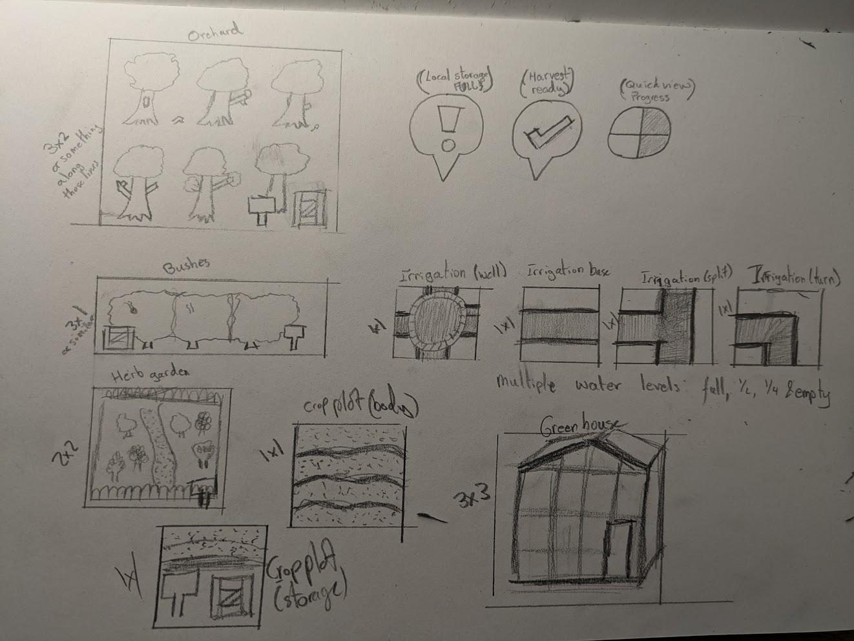

# 

# Farming implementation and crops

## Crops table

***This section is actively being altered and the information within it is likely to change.***

[The table will be populated with all crops in due course. The table may then receive updates as appropriate.]

| ***Crop name*** | ***License required*** | ***Farming type*** | ***Time to harvest*** | ***Units per harvest*** | ***Night cycle debuff*** | ***Maximum local Sstack*** |
| --- | --- | --- | --- | --- | --- | --- |
| Orange |  | Orchard | 2 |  | 6 |  |
| Apple |  | Orchard | 2 |  | 6 |  |
| Lemon |  | Orchard | 2 |  | 6 |  |
| Lime |  | Orchard | 2 |  | 6 |  |
| Pear |  | Orchard | 2 |  | 6 |  |
| Strawberry |  | Bushes | 2 |  | 6 |  |
| Raspberry |  | Bushes | 2 |  | 6 |  |
| Blueberry |  | Bushes | 2 |  | 6 |  |
| Blackberry |  | Bushes | 2 |  | 6 |  |
| Grapes (green) |  | Bushes | 2 |  | 6 |  |
| Grapes (red) |  | Bushes | 2 |  | 6 |  |
| Soy beans |  | Plots | 2 |  | 6 |  |
| Almond |  | Orchard | 2 |  | 6 |  |
| Potato |  | Plots | 2 |  | 6 |  |
| Sugar cane |  | Plots | 2 |  | 6 |  |
| Coffee beans |  | Plots | 2 |  | 6 |  |
| Tea leaves |  | Plots | 2 |  | 6 |  |
| Tomato |  | Greenhouse | 4 |  | 8 |  |
| Pineapple |  | Greenhouse | 4 |  | 8 |  |
| Mint |  | Herb | 4 |  | 8 |  |
| Basil |  | Herb | 4 |  | 8 |  |
| Cardamom |  | Herb | 4 |  | 8 |  |
| Cinnamon |  | Herb | 4 |  | 8 |  |
| Coriander |  | Herb | 4 |  | 8 |  |
| Cilantro |  | Herb | 4 |  | 8 |  |
| Ginger |  | Plot | 2 |  | 6 |  |
| Cocoa beans |  | Greenhouse | 4 |  | 8 |  |
| Hops |  | Plot |  |  |  |  |

## Resources table

***This section is actively being altered and the information within it is likely to change.***

For all the non crops

| Pumpkin spice |  |  |
| --- | --- | --- |
| Vanilla |  |  |
| Salt |  |  |
| Honey |  |  |

# 

# Production machines

## Abstract production system

***This section is actively being altered and the information within it is likely to change.***

In general, machines in the production world will take input resources and convert them into output resources after a given time. The efficiency of machines varies with the machines level by increasing capacity and shortening time per unit to convert the resources.

Input and output for the machines is expected to be directional and the asset **cannot** be rotated. *For these purposes, north is considered to be at the top of the screen / asset.*

The abstract production system should be set up so that child classes can inherit the following functionality:

* Setting / resetting recipes (optional for player)
* Input filtering
* Resource translation to output
* Conversion time (dependent on level and number of components)
* Internal storage
* Pause intake when local input storage full
* Pause production when local output storage full
* Manual on/off pause for machine (player driven)
* Local level and upgrade system (e.g. upgrading machine from lvl 1 to lvl 2).
* Interactions of types *provide, retrieve, take* and *give*.

Some of these requirements are player driven and will likely be UI based.

## Juicer

[Section will be populated in due course.]

## Slicer

[Section will be populated in due course.]

## Crusher

[Section will be populated in due course.]

## Strainer

[Section will be populated in due course.]

## Fermenter

[Section will be populated in due course.]

## Aging barrels

[Section will be populated in due course.]

## Washer

[Section will be populated in due course.]

## Mixing vat

[Section will be populated in due course.]

## Industrial cooker

[Section will be populated in due course.]

## Industrial chiller

[Section will be populated in due course.]

## Water processing unit

[Section will be populated in due course.]

## Dehydrator

[Section will be populated in due course.]

## Bottling unit

[Section will be populated in due course.]

## Transport pipes

[Section will be populated in due course.]

## 

# 

# Tavern interior

## Overview

The tavern interior is a 3D space including a number of tables (standard and high common styles), chairs, barstools and booths for seating arrangements; a single barspace with a front and secondary countertop; staircase (to an out of bounds upstairs); cellar; and, staff only area / kitchen.

The tavern should contain a number of rustic elements having wooden and stone themes. Lighting should be warmer with more orange and yellow hints with optional opportunities for harsher accent lighting in specific places such as over the secondary preparation counter. *(Exact details tbc, updates will be made here.)*

The tavern is also expected to have some number of *NPC*s as patrons of the tavern. These are generic patrons at this stage and are primarily an addition to complete the feel of the scene.

Gameplay is *(currently expected to be - definitive decision expected in the next 1.5 weeks)* from a first person perspective from behind the bar and into the cellar. Gameplay involves creating and serving drinks for customers using resources gathered and produced in the *external world*.

## 

## 

## Layout

The final layout of the *tavern interior* will likely change from the information listed below. Updates will be made to this document as appropriate.

The layout should include a number of individual assets that can be added to a scene:

* Cellar
* Bar area
* Bar counter with barstools
* Secondary counter
* Staff only area (interior not visible to player)
* Single group tables with chairs
* Booths suited for 4-6 people
* Common high counter table with barstools
* Staircase to upstairs (not accessible by player)
* Doorways to each area

The working idea is along the lines of that shown in the diagram below. **The secondary bar area (vertical, bottom right) should be replaced by further tables, booths or similar.**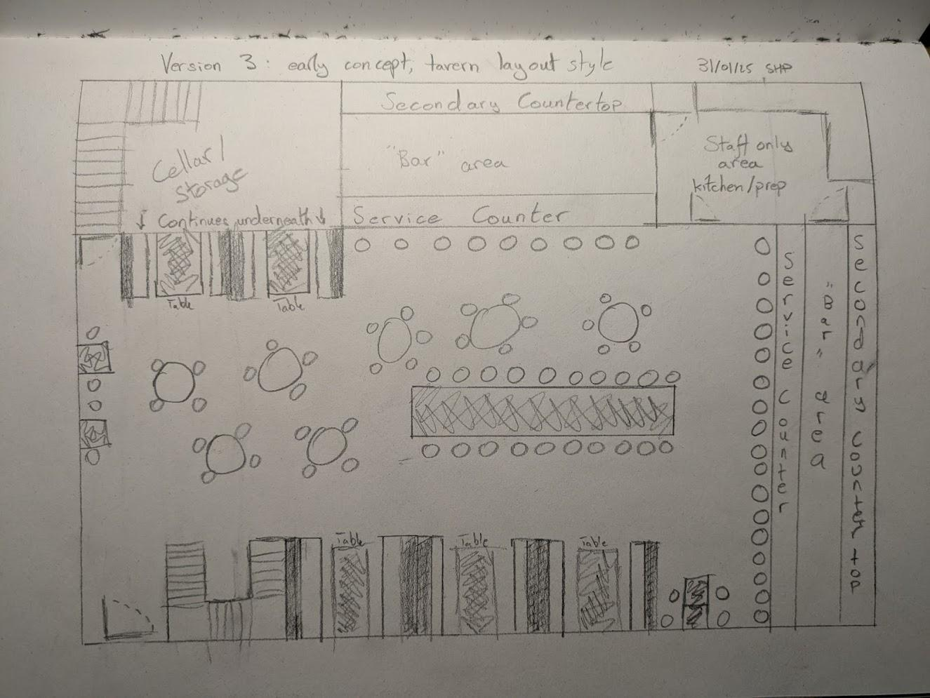

A designer will (hopefully, timing depending on scheduling) sit down with the 3D artist when the scene should be built to make the final layout with the artist.

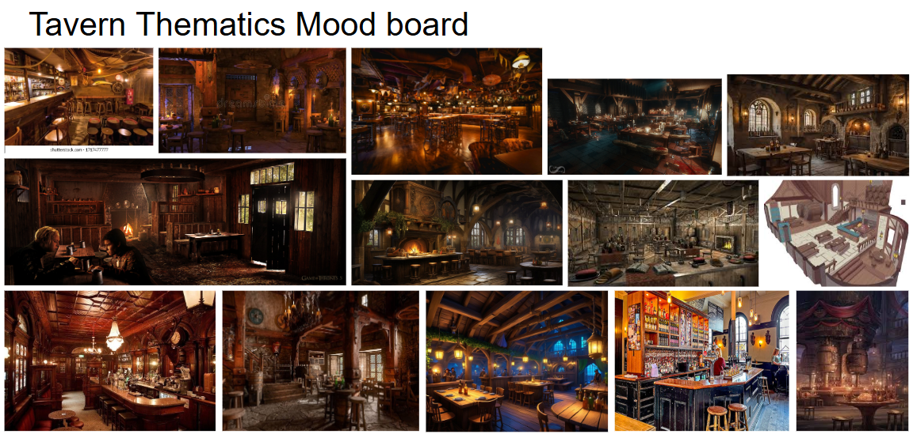

## 

## General seating area

While there are no specific notes for this area beyond those already listed in the layout section, basic concept art is available for some of the assets they aren’t the most specific and artistic discretion should be used where appropriate. They can be found below.

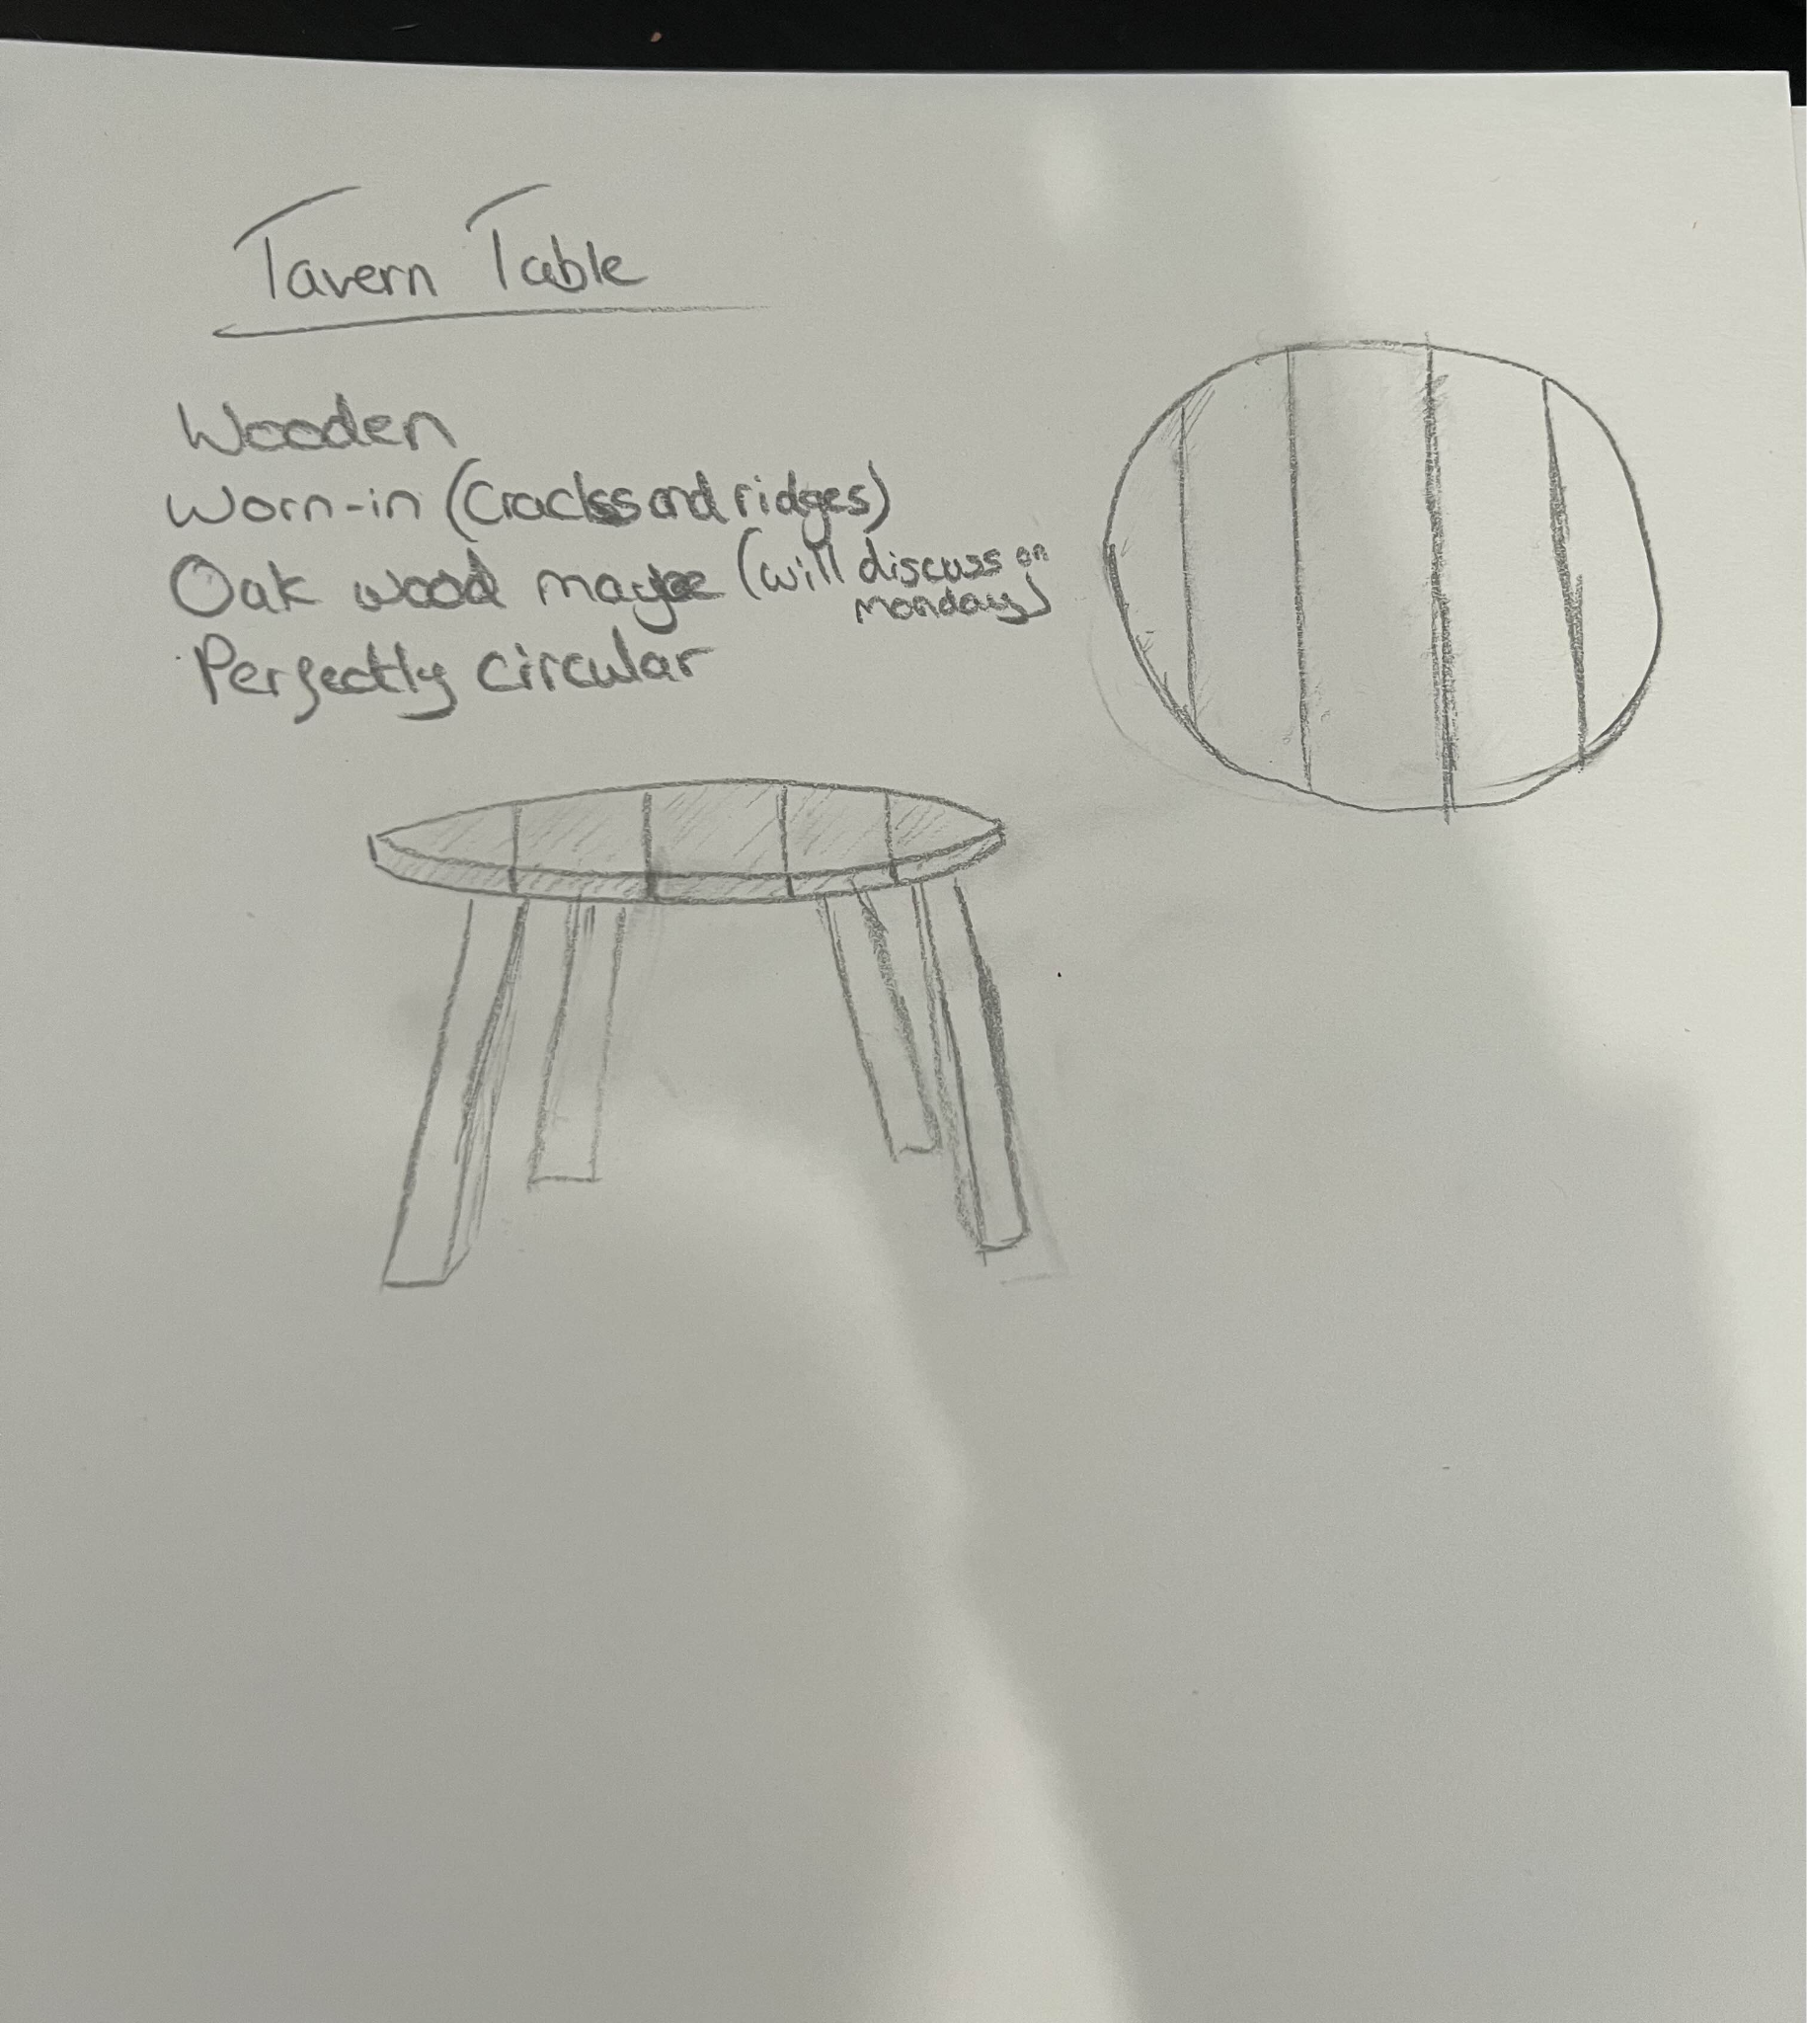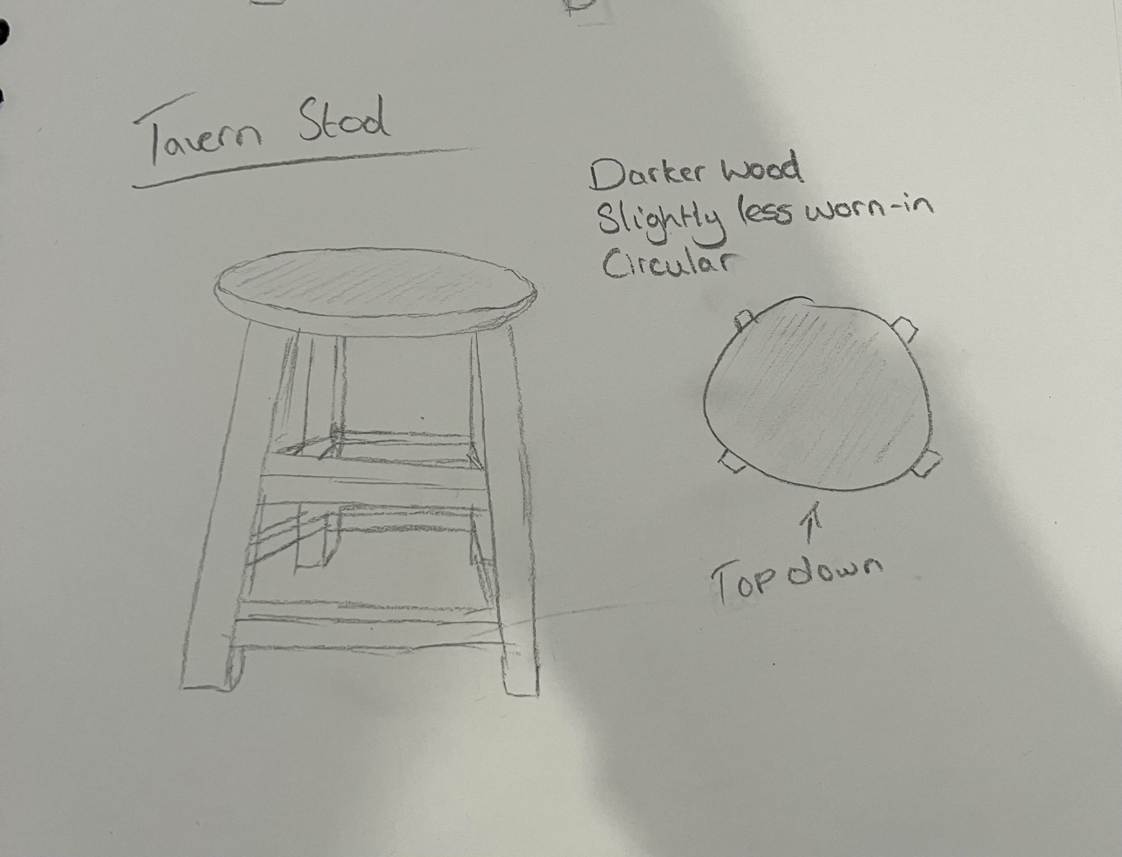

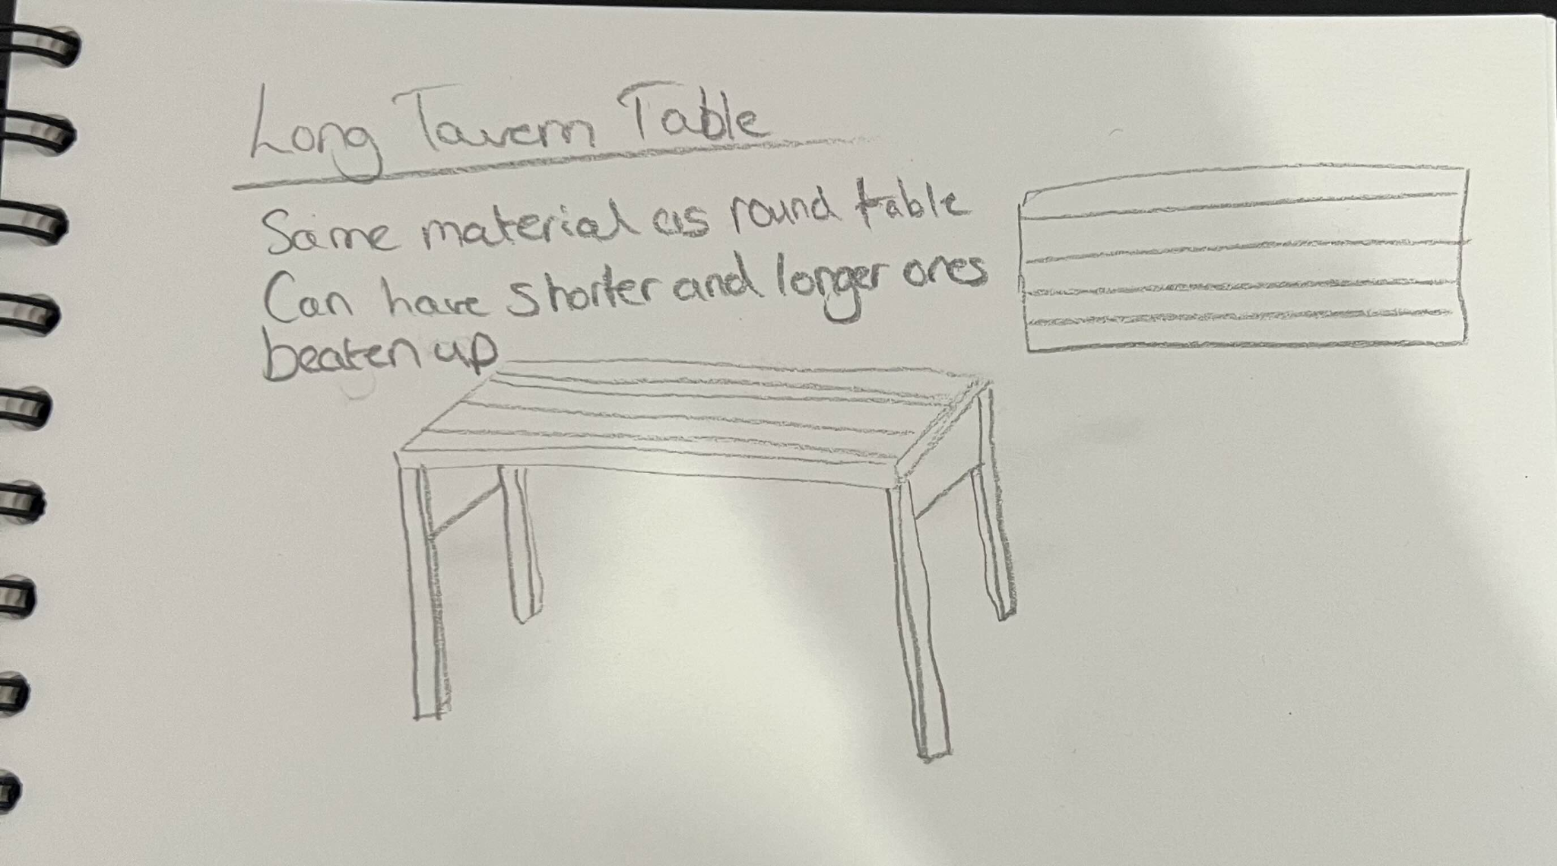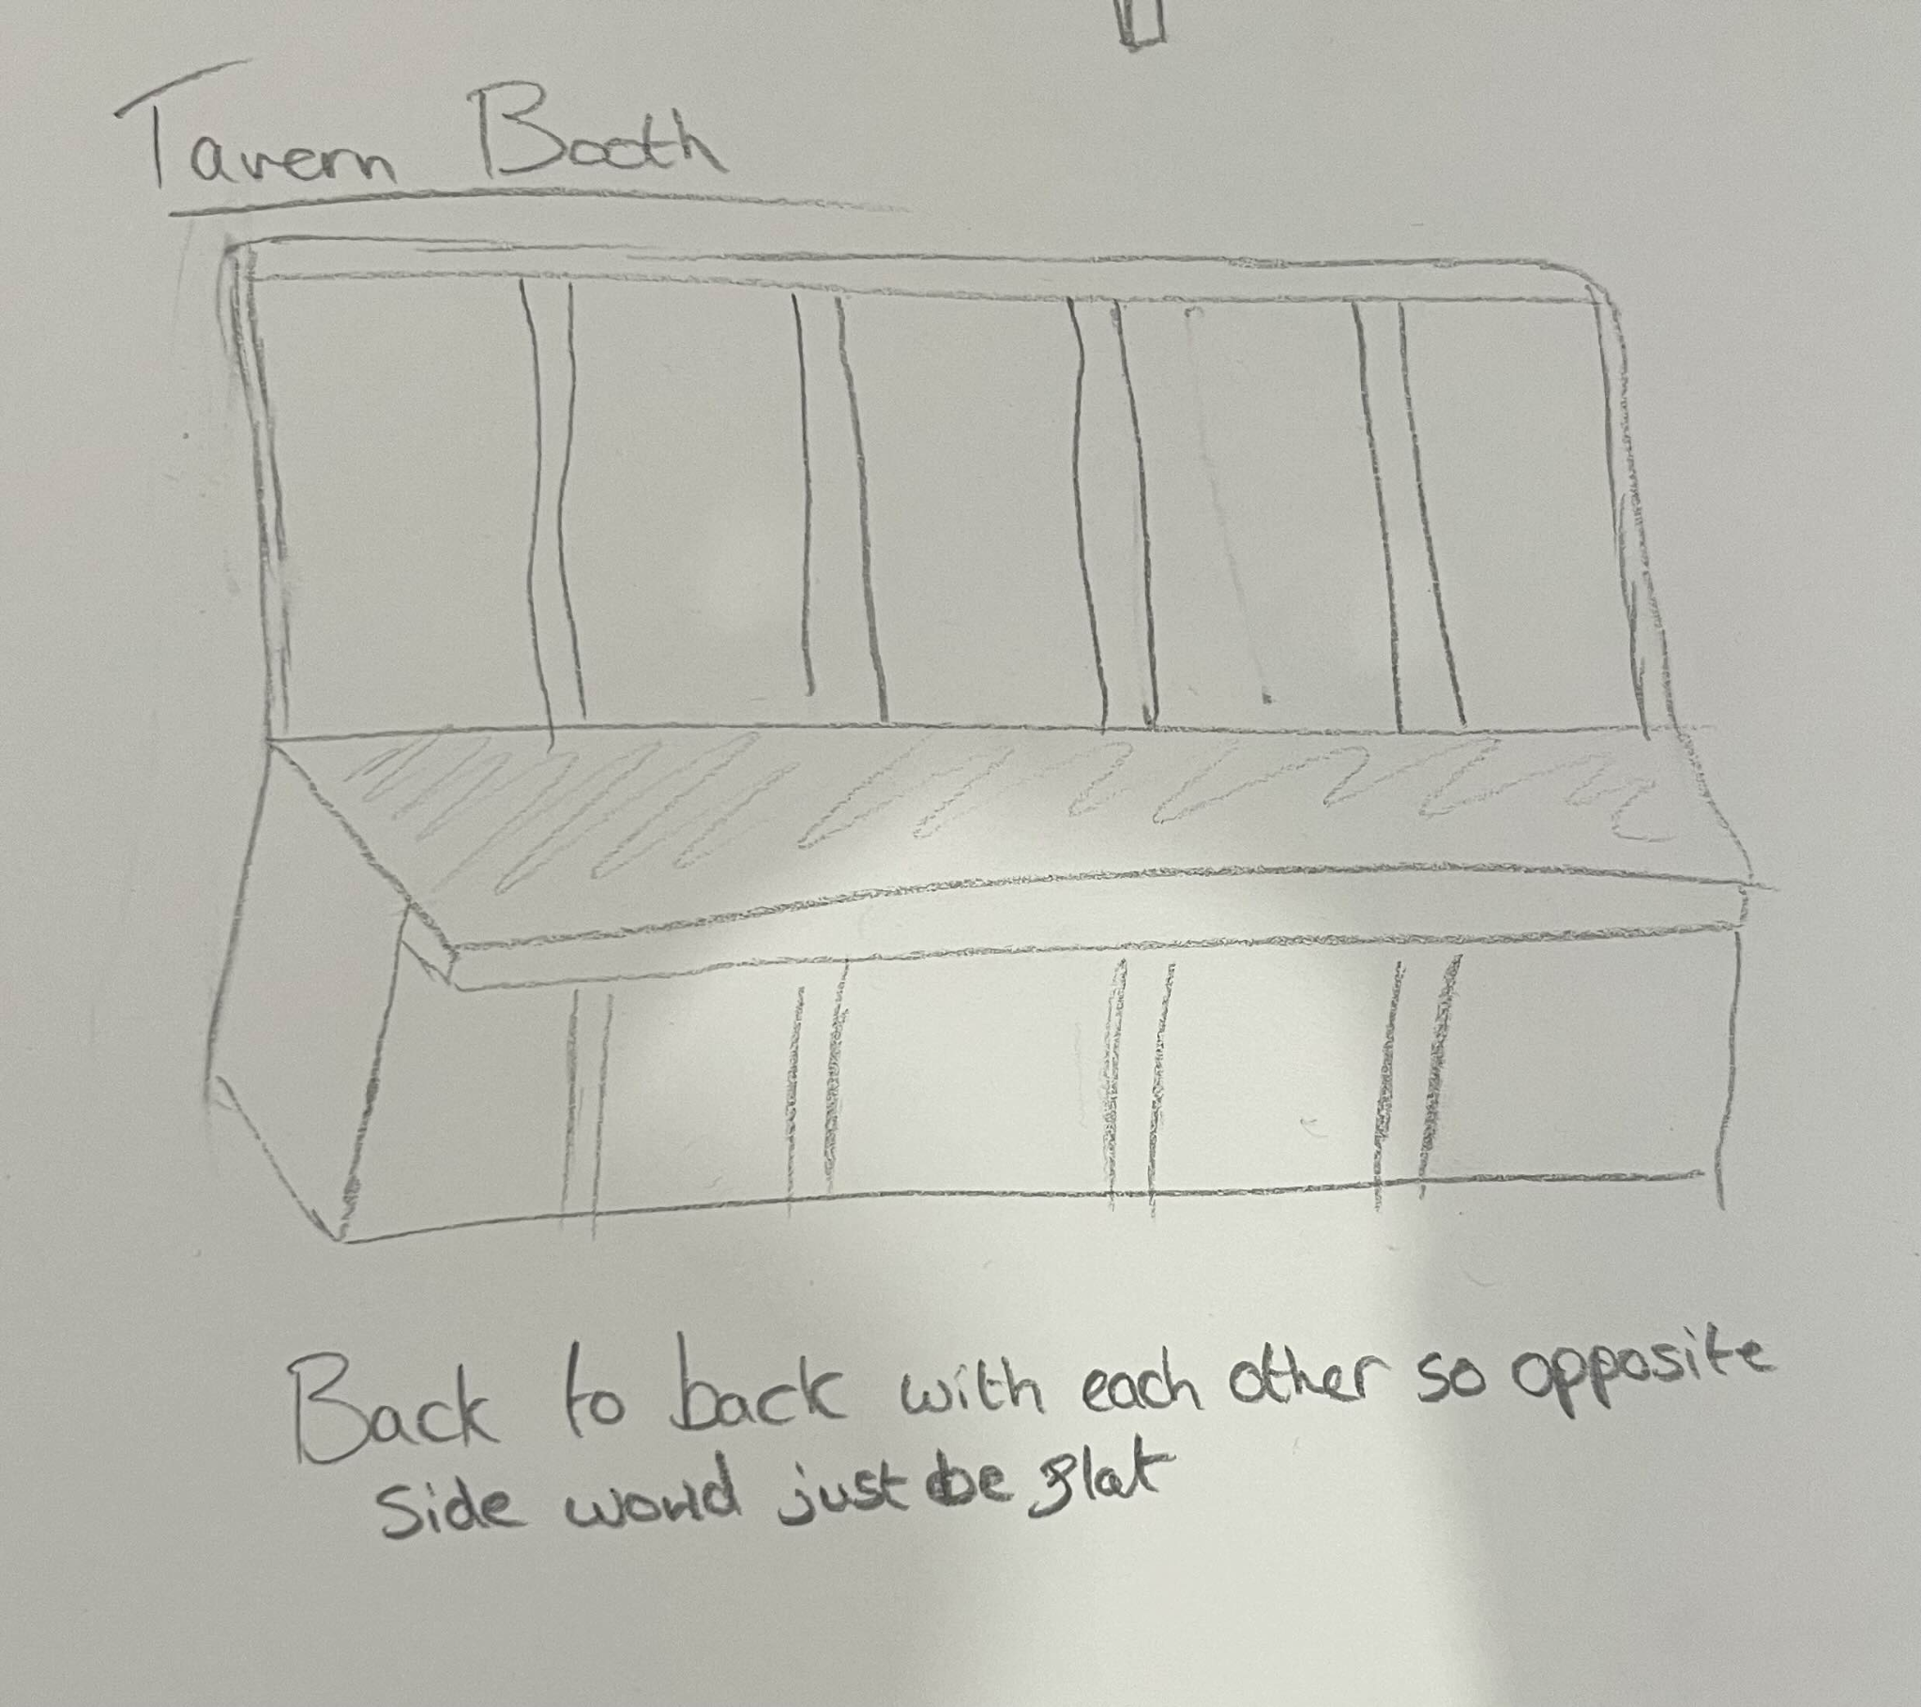

## Bar area

### Counter tops

Two countertops should be placed in the bar area. Preferably both harken to wooden themes with partially rounded edges.  
  
The bar counter should be more worn than the work counter and slightly narrower. The bar counter should also have an ice tray and glass cleaner built in to either one side or at each end of the counter. The bar should also include a set of draught taps. If time permits, some form of till would be preferable. The countertop should also overhang the wall beneath it slightly.

The secondary counter should be the wider of the pair of counters and should cover the top of the storage units. The counter should have a number of pieces of equipment (tea pots / coffee machine / cocktail set / chopping board with knife / etc - full list will be provided in a future update as appropriate, check with designers in the interim!)

### Storage units

Underneath the secondary preparation countertop, storage units should roughly be mirrored from each end. These should involve a series of draws, standard cupboard, fridge and freezer. It would be preferable if there is space between the two series of storage cabinets.

Above the counter, there should be a series of shelves to one side. These shelves would primarily be populated with different sets of glasses and a series of different bottles for drinks components like flavoured syrups.

The broad strokes ideas can be seen from an early stage concept art below. Some alterations should be noted from the above text as they have been made after the concept art was completed.

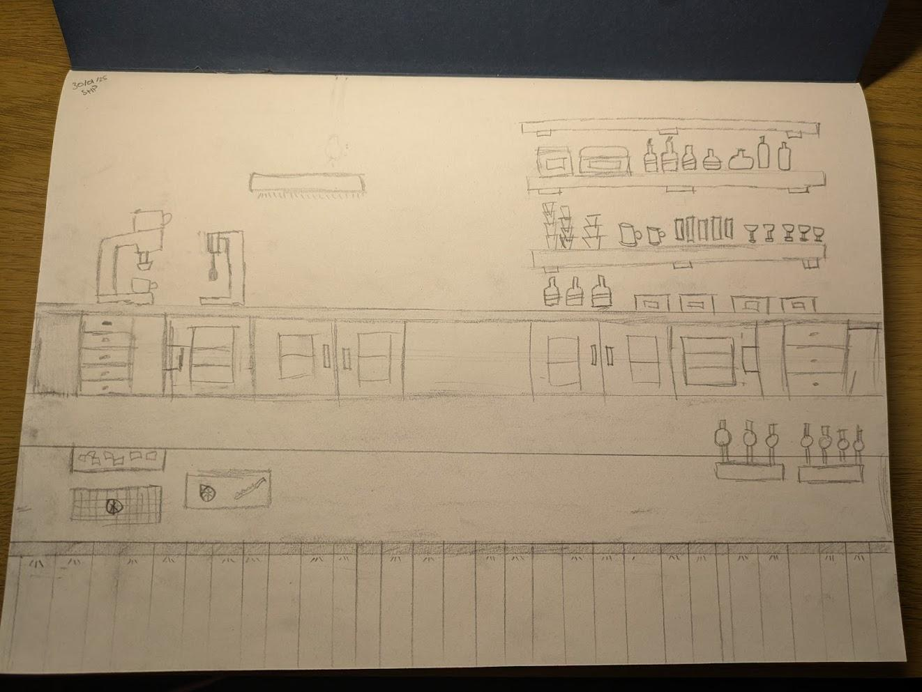

### Lighting

## Cellar

### Storage units

# Update record

Wed 05/02/25 - Skye:

*Redesigned the layout and streamlined functionality of the document. Added information to a number of standardisation elements, key structures in the external world, external world base tiling, farming abstract, and tavern interior overview.*

Thurs 06/02/25 - Skye:

*Continuation of information addition from previous update. Added tavern interior layout, other world structures, concept art for general seating area, bar area counters and storage, external world tile system, crop plots. Prepared a number of sections to be populated with design information in due course.*

Fri 07/02/25 - Skye:

*Amended the standardisation value for one tile for artists as agreed in discussion with the 2D team.*

Sun 09/02/25 - Skye:

*Added information to irrigation systems, orchards, bushes/vines, greenhouses and herb garden. Added the two irrigation checks and storage access checks to the farming standards.*

Mon 10/02/25 - Mikey:

*Updated the Crop table with how long each crop takes to grow. Added tavern interior mood board*

Wed 12/02/25 - Skye:

*Added the new section Universal game systems to be populated. Started work on EXP/proficiency, global tick and abstract production system.*

Wed 19/02/25 - Skye:

*Updated global ticks, day/night cycle and core inventory in accordance with results of discussions with the technical team. Redefined farming checks to be source based rather than sink based. Reworked the crop plot based on feedback from the technical team. Edited the external world time section to remove some redundancy with core day/night cycle section. Added production standards for machine interaction.*

*Improved formatting for farming structures and updated information to reflect updates in other sections. Updated information in abstract production system to reflect updates in other sections.*